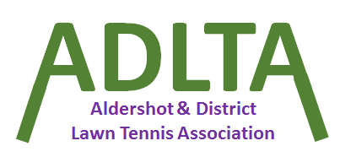

Proposals for the ADLTA AGM 7:30pm on 5th November 2025 at Avondale Tennis Club

Proposal 1: Frimley
To reintroduce the 10-point match tie break for Mens doubles, only, for the summer league.

Proposal 2: Ash

The abandonment rules should be the same for all matches, i.e. mens, ladies and mixed in both summer and winter:
2 Rubbers & 1st set of Matches 3 & 4 complete.

Proposal 3: Farnborough
We’d like to find a mutually satisfactory way to speed up matches in such a way as we can have a Championship Tie-break at one set all, so we propose trialling a change to midweek mixed matches in the 25/26 Winter league, with one of the following, based on a majority vote: -
a) Sudden death deuces, the server will serve to the player of the same gender.
b) One “normal” deuce followed by a sudden death deuce (as above) if the game isn’t won after the 1st deuce.

